**American International University-Bangladesh**

**Arham Chowdhury Kiass**

**ID: 20-42809-1**

**Data Science(D)**

**Dataset Sources**

[Salary Prediction dataset | Kaggle](https://www.kaggle.com/datasets/rkiattisak/salaly-prediction-for-beginer)

* **Dataset Input**

migraine<- read.csv("C:/data.csv",header = TRUE,sep = ",")

migraine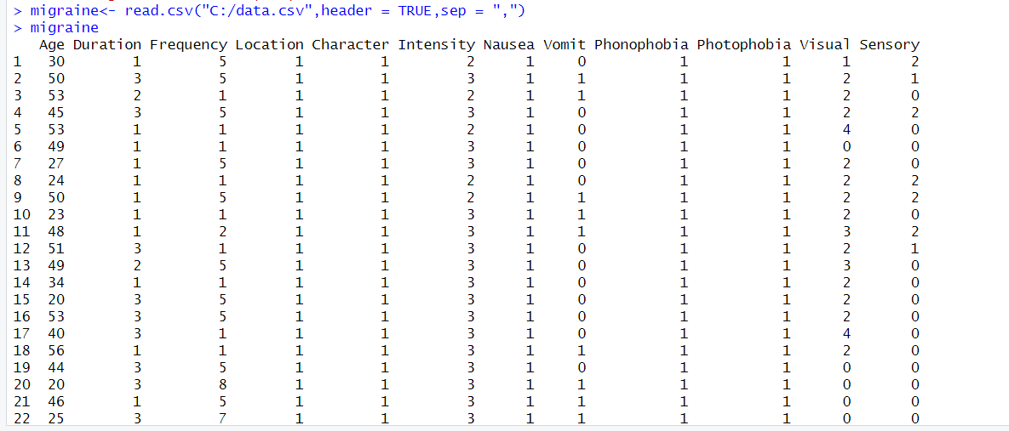

* **str(**migraine**)**

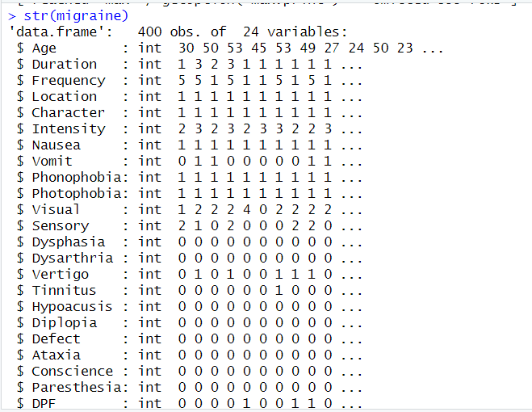

* **Dataset Scalling**

scale(migraine_new)

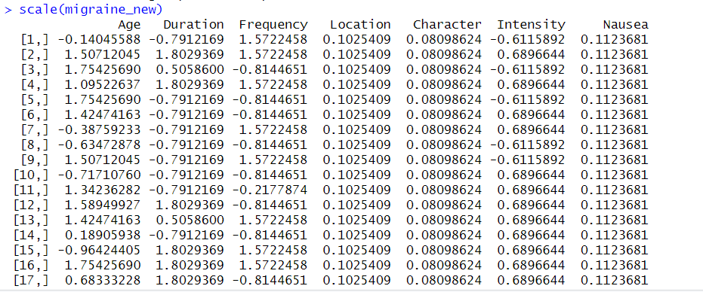

* **Remove Type**

migraine_new <- migraine[, -24]

migraine_new

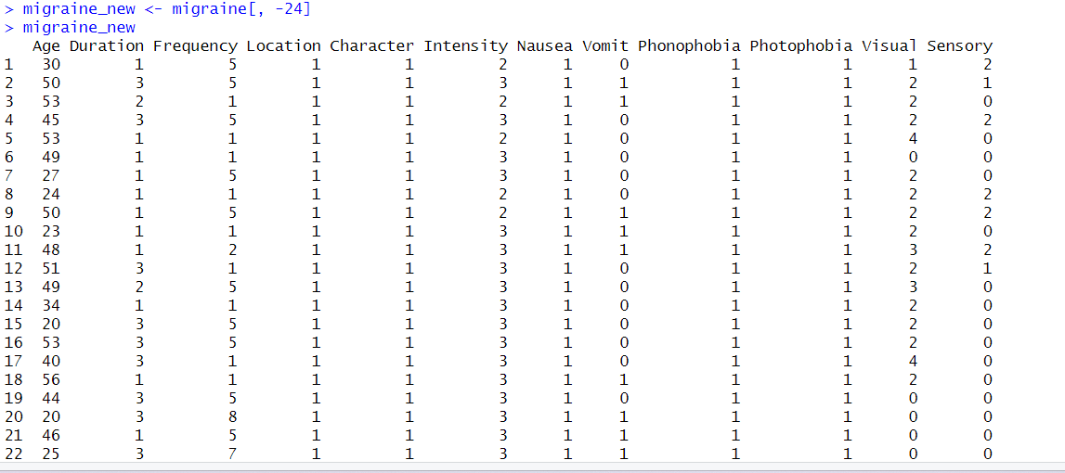

* **Finding zero from numeric dataset**

colSums(migraine_new == 0)

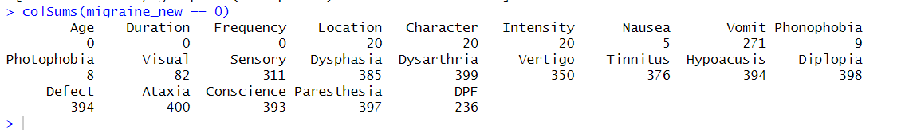

* **Removing Zero**

constant_cols <- which(colSums(migraine == 0) == nrow(migraine))

migraine_new <- migraine[,-constant_cols]

migraine_new

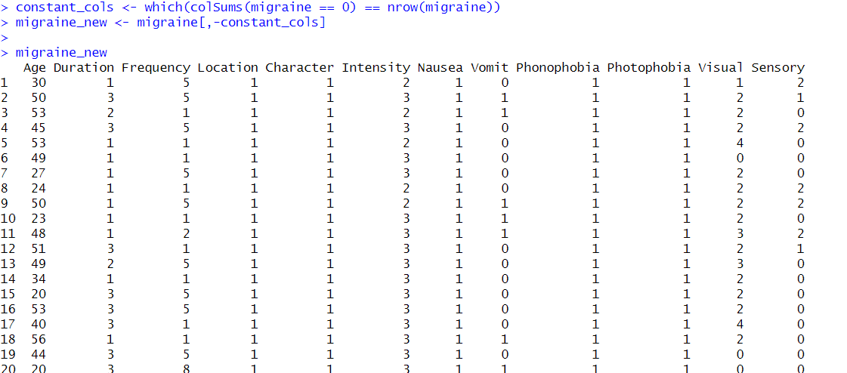

**installing packages**

install.packages("ClusterR")

install.packages("cluster")

install.packages("factoextra")

**Loading packages**

library(ClusterR)

library(cluster)

library(factoextra)

* **Optimal Number of Clusters**

fviz_nbclust(migraine_new, kmeans, method = "wss")

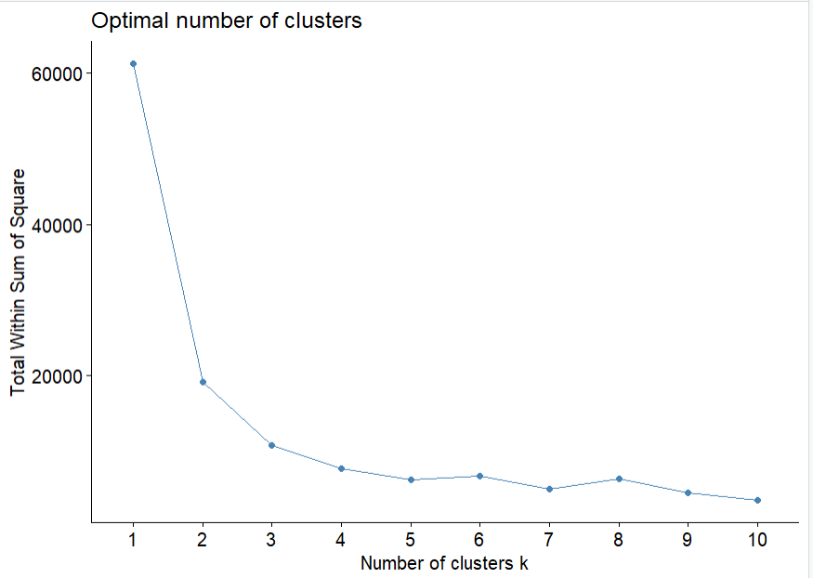

* **K-means Clustering Algorithm**

km <- kmeans(migraine_new, centers = 6, nstart = 30)

km

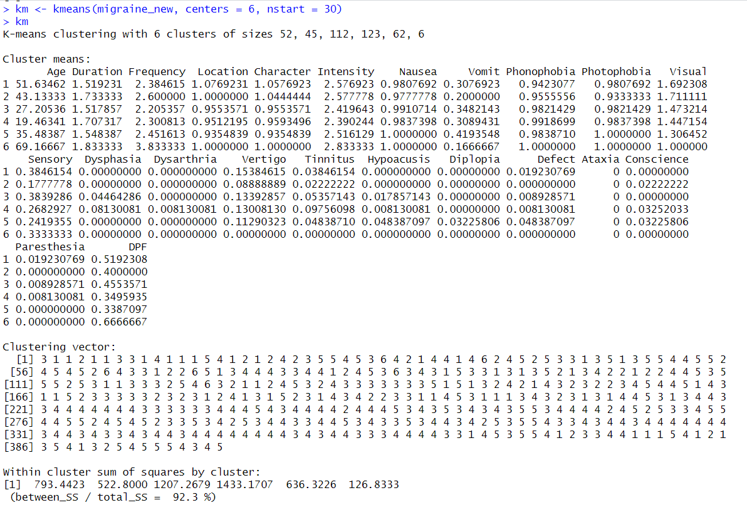

* **Visualize the output of K-means Clustering Algorithm**

k_clusters <- cbind(migraine_new, cluster = km$cluster)

k_clusters

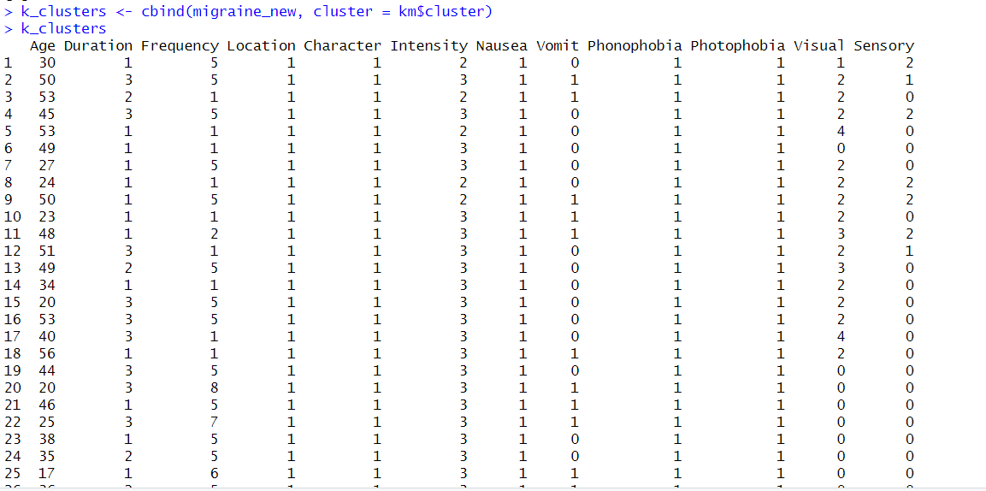

* **Visualize the output of K-means Clustering Algorithm**

library(dplyr)

migraine_new <- select_if(migraine_new, function(x) !all(x == 0))

fviz_cluster(km, data = migraine_new)

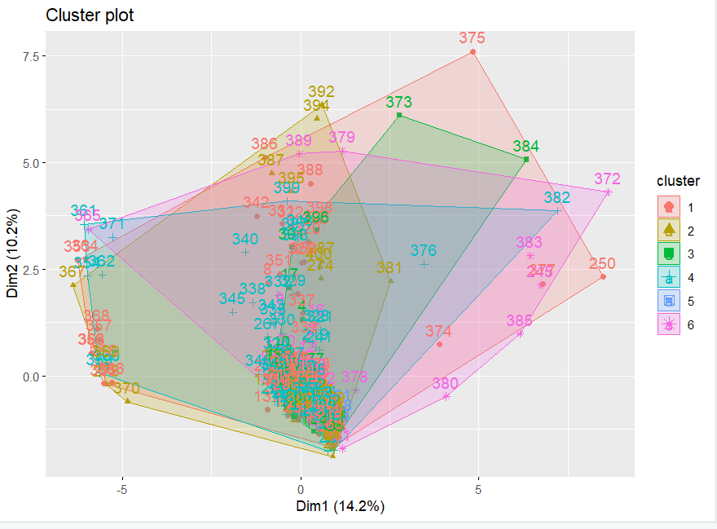

* **Find means of each cluster**

aggregate(migraine_new, by=list(cluster=km$cluster), mean)

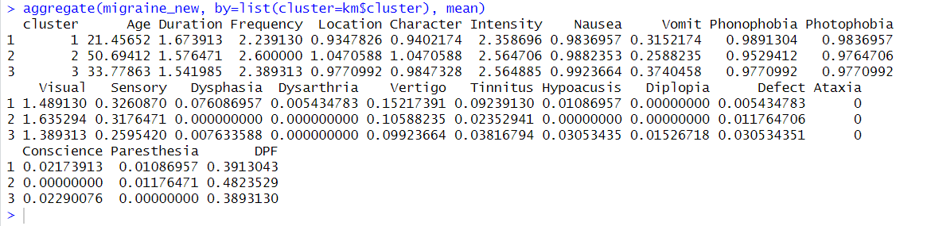

#hierarcical clustering

hc <- hclust(dist(migraine_new))

plot(hc)

